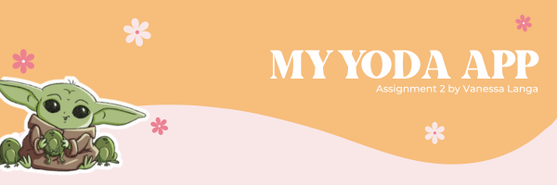

**IMAD5112 – Assignment 2**

**Vanessa Langa**

**6 May 2024**

**ST10247842**

**The purpose of the Yoda App**

According to CrowdBotics (2024), Applications that let users play games against each other on the web, mobile devices, or desktop are referred to as gaming applications. The ability to manage the game and communicate with friends may also be included in gaming apps. Casual and immersive games are the two main categories into which games are generally divided. I created my Yoda app which replicates the Tamagotchi App. According to the IIE (2024), “A Tamagotchi app is a clone of a popular 1990s virtual pet toy, Tamagotchi. It allows users to care for a virtual pet on their smartphones or digital devices”. The purpose of my Yoda app is to keep users entertained and give users the freedom to take care of their Yoda pet in their own way. The app gives users the platform to feed, clean and even play with their Yoda pet. The target audience for the Yoda app is manly children. According to Parents (2023), Children's brain growth can benefit from playing video games.2. As an illustration, I used to watch my son play Legend of Zelda video games when he was a young teenager. To move forward, he had to look for things, make plans, bargain, and try various strategies. Many other planning and problem-solving games, such Bakugan: Defenders of the Core, were being released at the same time I was conducting my research.   
Additionally, "modding," the process by which players create new game levels and alter their character's look, fosters innovative methods of emphasizing personalities and interests in addition to allowing for creative self-expression and a thorough comprehension of the rules and structure of the game. Therefore, even though video games aren't considered "educational," they can nonetheless teach kids how to make choices, employ methods, foresee outcomes, and express their individuality.

**The Design Considerations**

The Yoda app is an app that is designed for children. According to Unity (2023), fun gameplay greatly depends on a great user experience (UX). Players may become frustrated with menus and interfaces that are either overly complex or too simple to use. Your best option is to maintain the appearance and feel of your game consistent, easy to use, and basic.

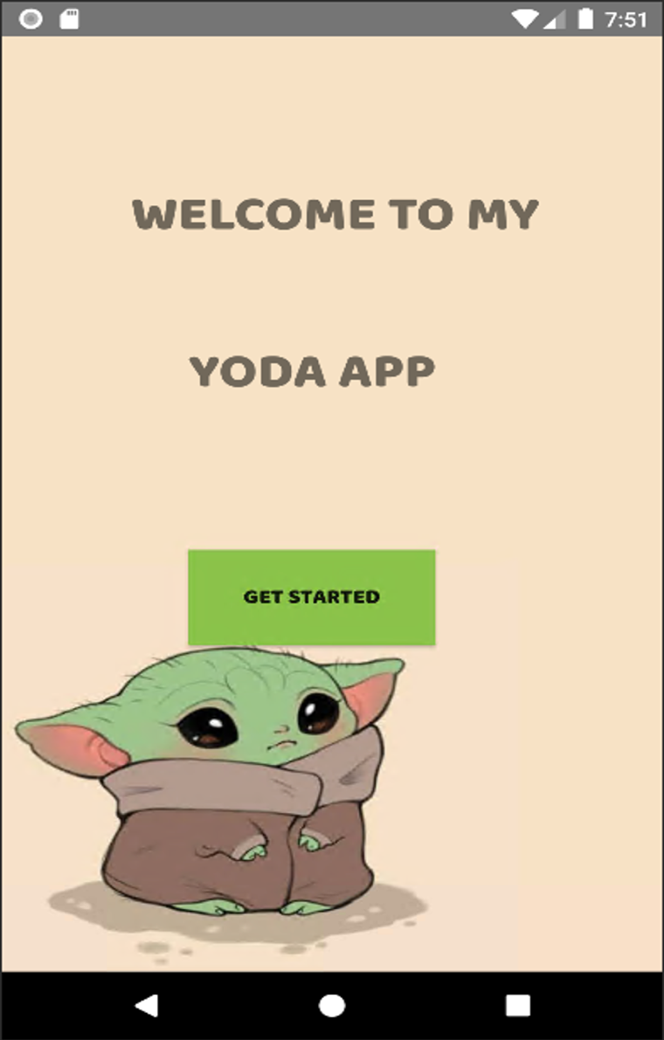

The background for my welcome page is (Main Activity Window) is aesthetically pleasing to the eye because it shows the Yoda pet which grabs the user’s attention because this is not an ordinary pet, its fictional. The Welcome message for the first page is in bold and big letters. According to Velocity Media (2024), to draw readers' attention to the text and highlight important passages, use bold. Strong emphasis is conveyed by using the bold tag. If you want to emphasize something in your writing, you should first think about using italics. If you're not happy with the emphasis the italics added, then use bold text. The get started button was designed for users to go to the next page (Page 2 Window) where all the fun takes place. The button is green to match the colour of the Yoda and start the activity for page 2. The design interface was created in Android studio. The pastel colours used in this app bring the whole idea of the Tamagotchi app to life.

**Welcome Page (Main Activity)**

The design for the welcome page works simple and effective so the user can understand the app. The pastel tones bring the whole idea of creating an app for children that is aesthetically pleasing to the eye. I used a Text view to illustrate the welcome message. I did not want to make the welcome message plain, so I made the welcome message bold with a font size of 40. The text is grey so it can stand out and not contrast the pastel yellow background. The button has constraints, so it doesn’t move any time the user clicks on it. The button is green, and I set it to this colour so it fits with the Yoda and the background. The button has the text “Get Started” in bold so users can click on it to go the Page 2 Activity.

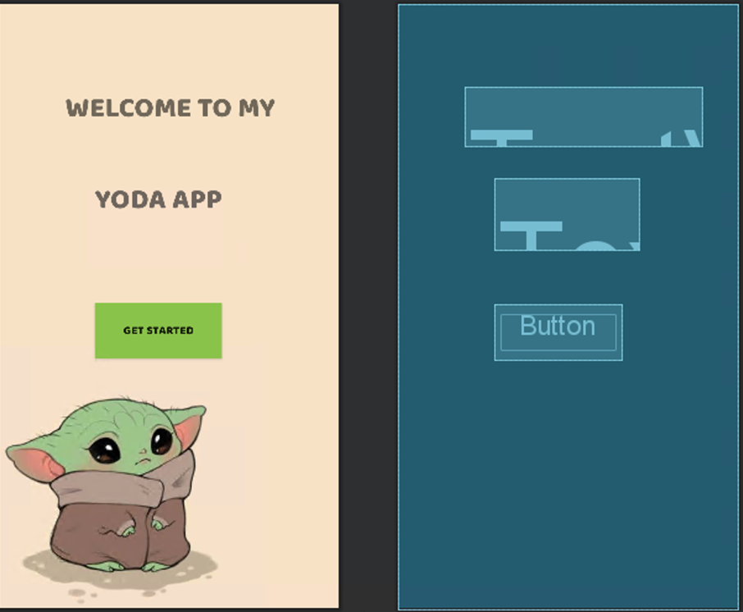

**The Game (Page 2 Activity)**

The design for the page 2 has a pastel light blue background and the status bars are dark blue. These two colours blend in because they are both blue and give light to the app. The status bars are in in the darker blue so the status of the Yoda app is shown in bold to grab the users attention. I designed the status bars in my background so its always appears. The images in page 2 activity change as the user clicks on the action buttons. The action buttons in this app are three, the feed, clean and play. As the user clicks on these action buttons, the image in the imagview will change to the action that matches the buttons. The images of the Yoda are bright in colour and grab the users attention.

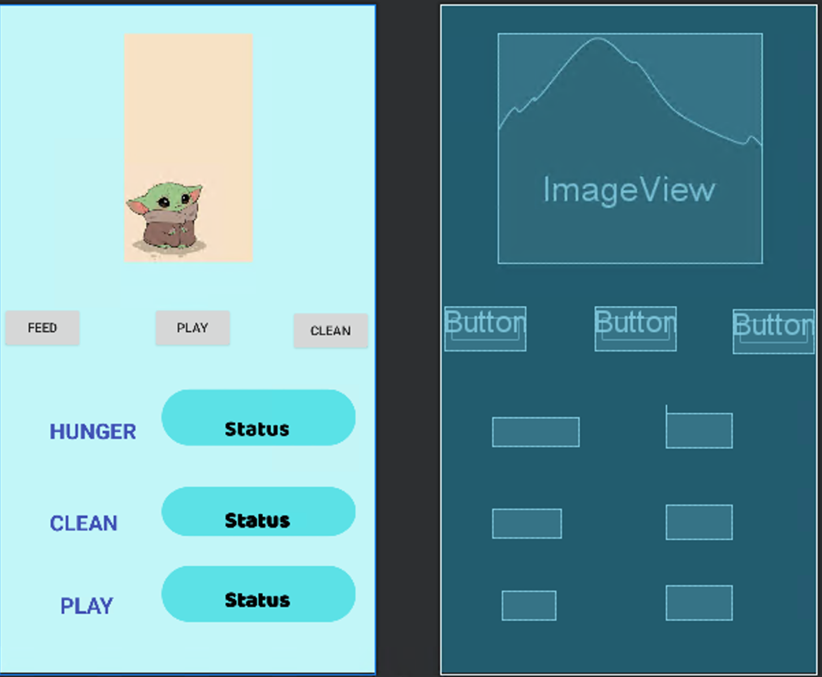

**Intuitive Design**

The applications is easy to follow. The controls are in simple image and big enough so the user can utilise them. The Welcome message is in bold. This welcome message shows the user that this is the beginning of the game making it easy for the user to follow the next step which is clicking the “get started” button. The action buttons are bold enough for the user to utilise. The images show the actions that match the buttons. The buttons are easy to understand. All the user needs to do is tap on the buttons and the image will change.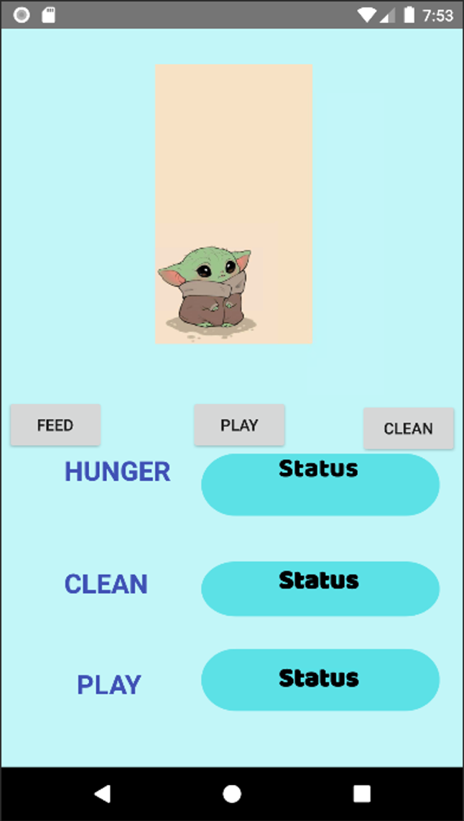

**GitHub Actions**

As we needed to push our code to GitHub follow the steps of:

1. Make a repository, which is initialized with a README file.
2. Then pushing my Android Application from Android studio to GitHub, through the file management. Opening the application file
   1. At the top where path is show, click file, type CMD
   2. git init
   3. git add .
   4. git commit -m “final commit”
   5. git branch -M main
   6. git remote add origin **repository URL**
   7. git push -u origin main

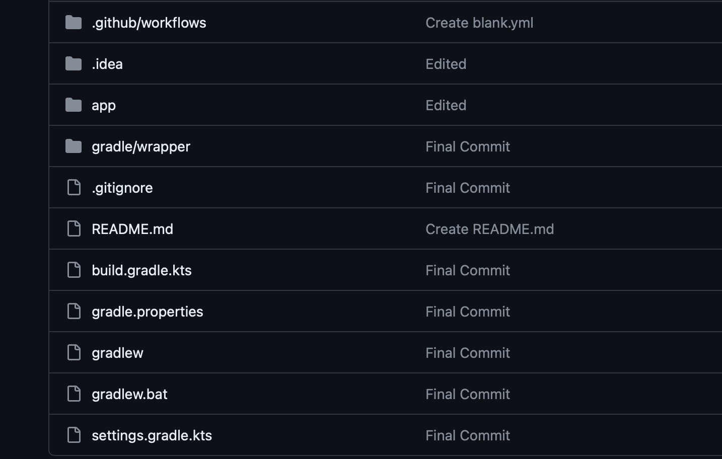

**YouTube link**

<https://youtu.be/kzYsI6yOyKI>

**Reference List**

**Books**

The Independent Institute of Education, 2024. Introduction to Mobile Application Development Module Manuel. Pretoria. South Africa.

**Website**

Crowd Botics. 2024. Gaming App Cost, 7 May 2024. [Online]. Available at <https://crowdbotics.com/posts/cost-to-build/gaming-app/#:~:text=A%20gaming%20application%20is%20a,games%20or%20immersive%2C%20engaging%20games> [Accessed 7 May 2024].

Parents. 2023. 9 Benefits of Kids Playing Video Games, 5 September 2023. [Online]. Avaialable at <https://www.parents.com/kids/development/benefits-of-video-games/#:~:text=The%20content%20of%20certain%20video,parents%20are%20alert%20to%20opportunities> [Accessed 7 May 2024].

Unity. 2023. 10 Game Design Tips for New Developers, 29 June 2013. [Online]. Available at <https://unity.com/how-to/beginner/10-game-design-tips-new-developers> [Accessed 7 May 2024].

Velocity. 2024. Blog Posts, 7 May 2024. [Online]. Available at <https://velocitymedia.agency/latest-news> [Accessed 7 May 2024].